**Software Engineering Assignment**

------------------------------------------------------------------------------------------------------------------

**MODULE: 1**

-----------------------------

**SE – Overview of IT Industry**

----------------------------------------------------------------

**1) What is software? What is software engineering?**

=> Software:

-set of instructions (input) to be executed (process)for specific task (output).

=> Software Engineering:

-Process to develop any software based on the engineering principles.

**2) Explain types of software**

1) System Software:

-In built software. No need to install or download. They are provided by the system itself.

e.g. notepad, notes, clock, calendar

2) Application Software:

-Need to install or download to use. It is provided by the developers.

e.g. Instagram, WhatsApp, LinkedIn

3) Driver software

-Example: Audio Driver, Video Driver etc.

4) Middleware

-Interaction between system software & app. software

5) Programming software

-Used for program execution purpose.

e.g. Compiler, interpreter

**3) What is SDLC? Explain each phase of SDLC**

=> SDLC: Software Development Life Cycle: -SDLC is a step-by-step approach to develop any product/software with high quality, in shortest possible time and within the estimated budget.

-SDLC methodology focuses on the following phases of software development:

1. Planning/ Requirement Gathering

2. Analysis

3. Designing

4. Implementation

5. Testing

6. Maintenance

=> Planning/ Requirement Gathering:

-Requirement Gathering in the SDLC is the process of identifying, collecting, and documenting the specific needs and expectations of client for a software system or project.

=> Analysis:

-Developer are analysis requirement client.

-Developer create software requirement specification (SRS) does not change requirement client.

=> Designing:

-The design phase defines how a software application will work.

-DFD, ER Diagram, Flowchart, Use case

=> Implementation:

-Developers build the software according to the design specifications.

-The outcome is a working version of the software.

=> Testing:

-Client meets the requirement and work from backend side a project implementation or development.

=> Maintenance:

-Maintenance also covers software updates and optimization for better performance.

**4. What is DFD? Create a DFD diagram on Flipkart**

**=>DFD:** Data flow diagram

- The flow of data of a system or a process is represented by DFD

- Level 0 DFD of Flipkart:

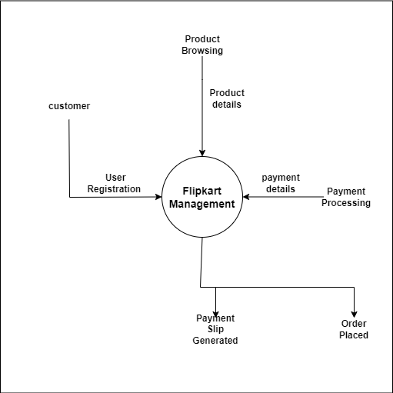

-Level 1 DFD of Flipkart:

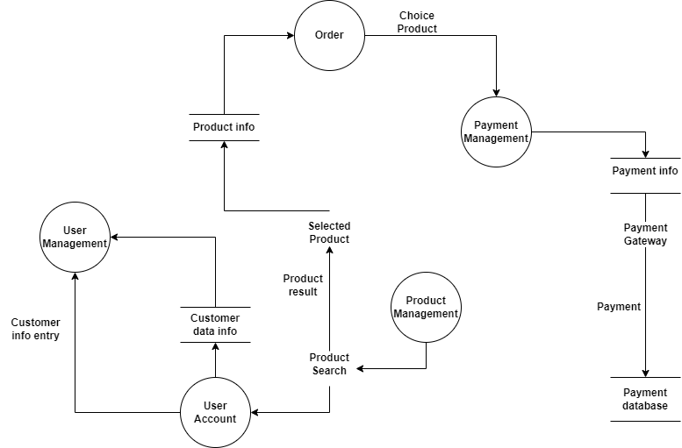

->Level 2 DFD of Flipkart:

-User Management:

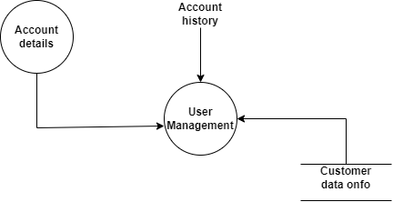

-Payment Management:

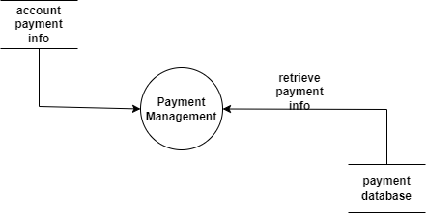

-Product Management:

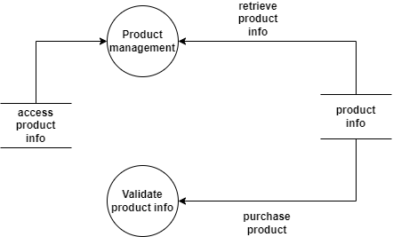

**5. What is Flow chart? Create a flowchart to make addition of two numbers**

=> Graphical representation about the algorithm.

- Flowchart is a step-by-step approach to solving a task. -Two numbers addition of flowchart. 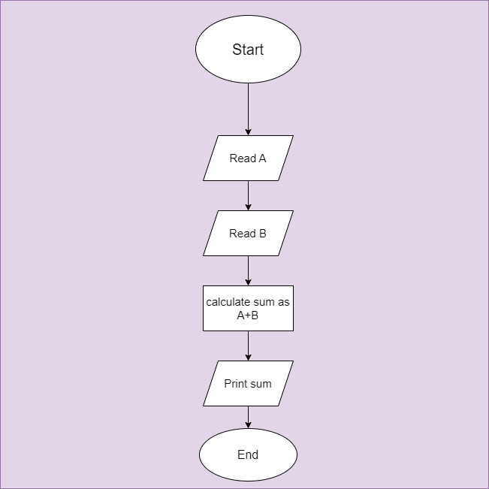

**6. What is Use case Diagram? Create a use-case on bill payment on Paytm.**

=> sequence of actions performed by the actors.

- A use case is a written description of how users will perform tasks on your website.

